Chapter 6
The Memory Hierarchy
To this point in our study of systems, we have relied on a simple model of a computer system as a CPU that executes instructions and a memory system that holds instructions and data for the CPU. In our simple model, the memory system is a linear array of bytes, and the CPU can access each memory location in a constant amount of time. While this is an effective model as far as it goes, it does not reflect the way that modern systems really work.
In practice, a memory system is a hierarchy of storage devices with different capacities, costs, and access times. CPU registers hold the most frequently used data. Small, fast cache memories nearby the CPU act as staging areas for a subset of the data and instructions stored in the relatively slow main memory. The main memory stages data stored on large, slow disks, which in turn often serve as staging areas for data stored on the disks or tapes of other machines connected by networks.
Memory hierarchies work because well-written programs tend to access the storage at any particular level more frequently than they access the storage at the next lower level. So the storage at the next level can be slower, and thus larger and cheaper per bit. The overall effect is a large pool of memory that costs as much as the cheap storage near the bottom of the hierarchy, but that serves data to programs at the rate of the fast storage near the top of the hierarchy.
As a programmer, you need to understand the memory hierarchy because it has a big impact on the performance of your applications. If the data your program needs are stored in a CPU register, then they can be accessed in zero cycles during the execution of the instruction. If stored in a cache, 1 to 30 cycles. If stored in main memory, 50 to 200 cycles. And if stored in disk tens of millions of cycles!
Here, then, is a fundamental and enduring idea in computer systems: If you understand how the system moves data up and down the memory hierarchy, then you can write your application programs so that their data items are stored higher in the hierarchy, where the CPU can access them more quickly.
This idea centers around a fundamental property of computer programs known as locality. Programs with good locality tend to access the same set of data items over and over again, or they tend to access sets of nearby data items. Programs with good locality tend to access more data items from the upper levels of the memory hierarchy than programs with poor locality, and thus run faster. For example, the running times of different matrix multiplication kernels that perform the same number of arithmetic operations, but have different degrees of locality, can vary by a factor of 20!

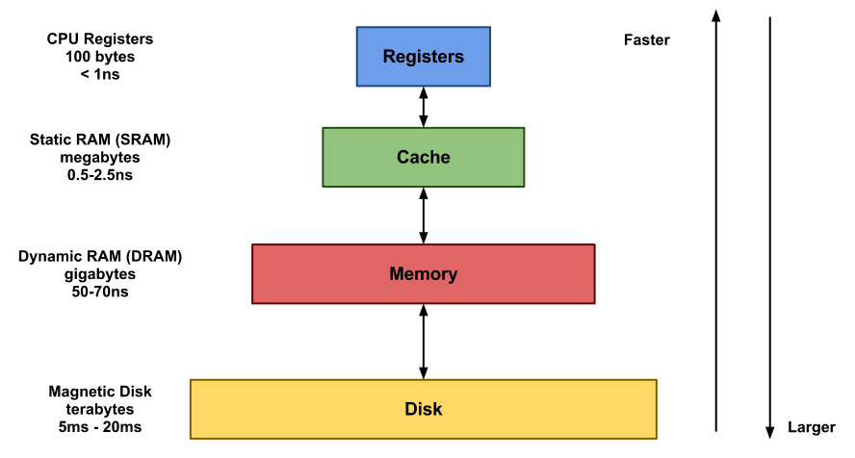
It can be noted that the larger the memory, the slower the data access.

6.1 Storage Technologies
Much of the success of computer technology stems from the tremendous progress in storage technology. Early computers had a few kilobytes of random-access memory. The earliest IBM PCs did not even have a hard disk. That changed with the introduction of the IBM PC-XT in 1982, with its 10-megabyte disk. By the year 2010, typical machines had 150,000 times as much disk storage, and the amount of storage was increasing by a factor of 2 every couple of years.
Glosario: To stage: montar / manipular

EJERCICIO 4
Las expresiones subrayadas a lo largo del texto tienen en común que expresan:
(Alguna forma de) comparación
- ¿Podría agruparlas? Complete.

Comparación de Adjetivos:
lower - slower - larger - cheaper -
higher Comparación de Adverbios:
faster - more quickly
more frequently
Adjetivos superlativos:
The earliest
The most frequently used Otras formas de comparación:
as much as - as far as
the larger ……….., the slower
- Ahora traduzca las frases completas al español.

- the most frequently used data
……………más frecuentemente usados……………………………………………..
- programs tend to access the storage at any particular level more frequently than….
…………… más frecuentemente que ………………………………………………..
the next lower level
…el siguiente nivel más bajo/inferior…………………………………………………..
- the storage at the next level can be slower, and thus larger and cheaper per bit…
……puede ser más lento, por lo tanto más grande y más barato por bit.…………
- their data items are stored higher in the hierarchy
………son almacenados en la jerarquía en un nivel superior/ mas alto….
- the CPU can access them more quickly
……………………puede acceder a ellos más rápido / rapidamente……………...
- Programs with good locality tend to access more data* items from the upper levels of the memory hierarchy than programs with poor locality, and thus run faster.
………más datos……….de niveles superiores …………ejecutarse más rápido………
- The earliest IBM PCs
……………………………las primeras ….…………………………………………………….

C. ¿Qué indica more en more data *? ¿Qué valor tiene?
“More* aquí expresa cantidad. Compara distintas cantidades (de sustantivos)

EJERCICIO 5
Complete brevemente con información del texto.

- En la actualidad, la manera en que funcionan los sistemas modernos no se ve reflejada en el sistema sencillo que se considera hasta el momento/ que consideramos en el presente.
- Los programas con buena localidad son más rápidos debido a que normalmente acceden a datos almacenados en los niveles superiores de la jerarquía de las memorias.
- A partir de 1982, con la PC de IBM el almacenamiento en disco comenzó a crecer considerablemente.

EJERCICIO 6
¿Causa o consecuencia?
Complete las oraciones de la grilla con información del texto. Luego analice.

Causa (condición) | Consecuencia
Si la información que tu programa necesita está almacenada en el registro de la CPU, | puede acceder a la información en tus programas sin usar ciclos.
Si los datos están guardados en la memoria cache | se necesitará de 1 a 30 ciclos.
Si la información esta guardada en la memoria principal, | entonces se necesitarán de 50 a 200 ciclos.
Si está almacenada en el disco, | se necesitarán decenas de millones de ciclos.

EJERCICIO 7
Observe nuevamente la figura.
- ¿Es posible comprender la figura sin leer el texto?
Sí. Es clara/ se puede.
B. Explique qué información suministra la pirámide.
La figura presenta los tipos de memoria ordenados según su tamaño y su velocidad de acceso. La figura nos muestra la relación ascendente o descendente según de donde se mire entre tamaño y velocidad de acceso, cuánto mayor la memoria más lenta la velocidad de acceso y viceversa.

